Lab 14: Joining Tables

Part 1. Setup

Step 1. Create a schema and the tables
DROP SCHEMA IF EXISTS lab14 CASCADE;
CREATE SCHEMA lab14;
SET search_path TO lab14;
CREATE TABLE customers (
customer_id SERIAL PRIMARY KEY,
name VARCHAR(100),
email VARCHAR(100)
);
CREATE TABLE orders (
order_id SERIAL PRIMARY KEY,
customer_id INTEGER REFERENCES customers(customer_id),
order_date DATE,
total_amount DECIMAL(10,2)
);
CREATE TABLE products (
product_id SERIAL PRIMARY KEY,
product_name VARCHAR(100),
price DECIMAL(10,2)
);
CREATE TABLE order_items (
order_id INTEGER REFERENCES orders(order_id),
product_id INTEGER REFERENCES products(product_id),
quantity INTEGER,
PRIMARY KEY (order_id, product_id)
);
CREATE TABLE customer_profiles (
customer_id INTEGER PRIMARY KEY REFERENCES customers(customer_id),
phone VARCHAR(20),
city VARCHAR(50)
);
CREATE TABLE employees (
employee_id SERIAL PRIMARY KEY,
name VARCHAR(100),
manager_id INTEGER REFERENCES employees(employee_id)
);

Step 2. Insert sample data
INSERT INTO customers (name, email) VALUES
('Aibek Sharshenov', 'aibek@gmail.com'),
('Ainura Toktomamatova', 'ainura@gmail.com'),
('Bakyt Mamatov', 'bakyt@company.kg'),
('Gulzat Sultanova', 'gulzat@mail.ru'),
('Emir Uulu', 'emir@mail.ru');
-- the last order has no customer (customer_id is NULL)
INSERT INTO orders (customer_id, order_date, total_amount) VALUES
(1, '2023-12-20', 80.00),
(1, '2024-02-10', 250.00),
(2, '2024-03-05', 120.00),
(3, '2024-04-18', 60.00),
(NULL, '2024-05-01', 300.00);
INSERT INTO products (product_name, price) VALUES
('Laptop', 1200.00), ('Phone', 800.00), ('Headphones', 150.00);
INSERT INTO order_items (order_id, product_id, quantity) VALUES
(1, 3, 1), (2, 2, 1), (2, 3, 2), (3, 1, 1), (4, 3, 1);
INSERT INTO customer_profiles (customer_id, phone, city) VALUES
(1, '+996 555 111 222', 'Bishkek'),
(2, '+996 700 333 444', 'Osh'),
(3, '+996 770 555 666', 'Karakol');
INSERT INTO employees (name, manager_id) VALUES
('Bakyt Mamatov', NULL),
('Aibek Sharshenov', 1),
('Meerim Bekova', 1),
('Nursultan Isakov', 2);

Step 3. View the customers table
SELECT * FROM customers;
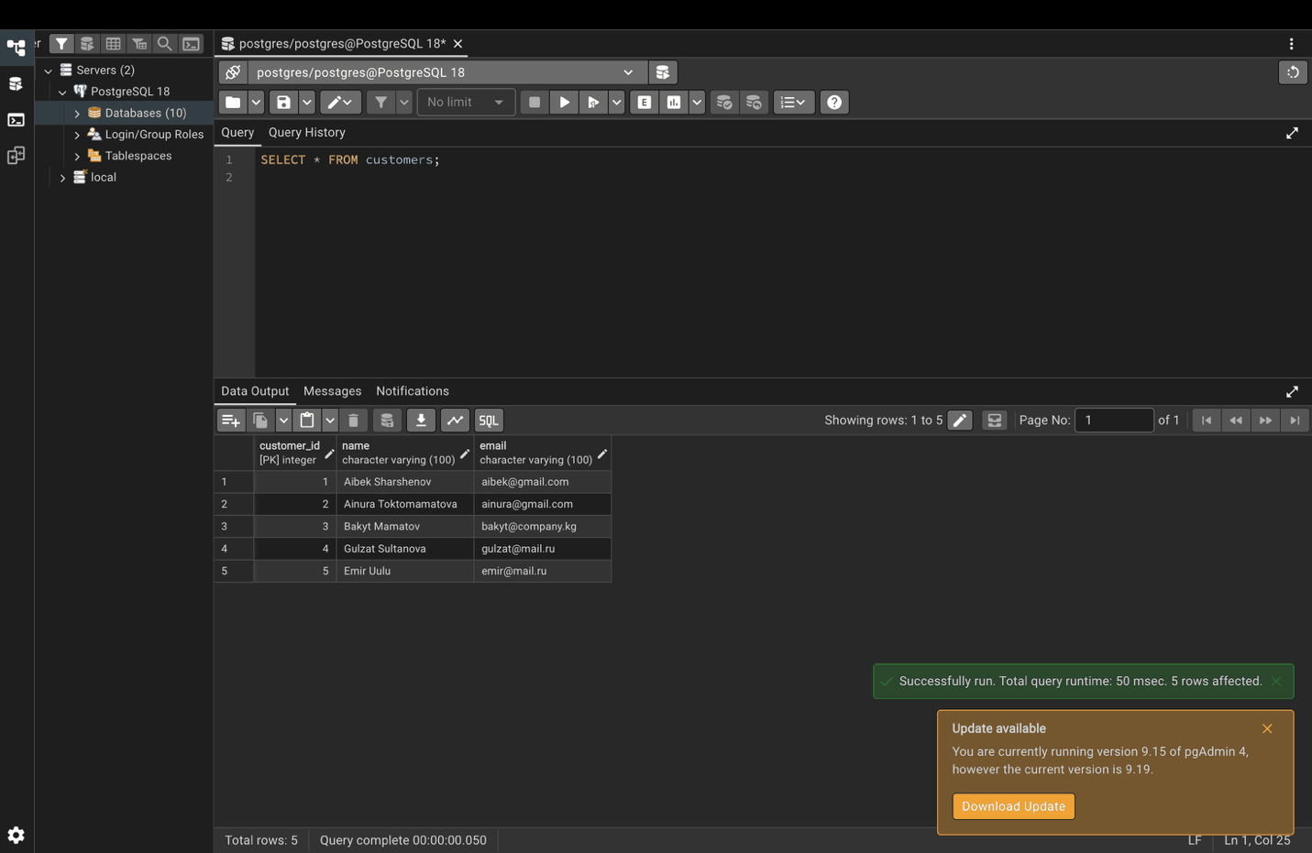

Step 4. View the orders table
SELECT * FROM orders;
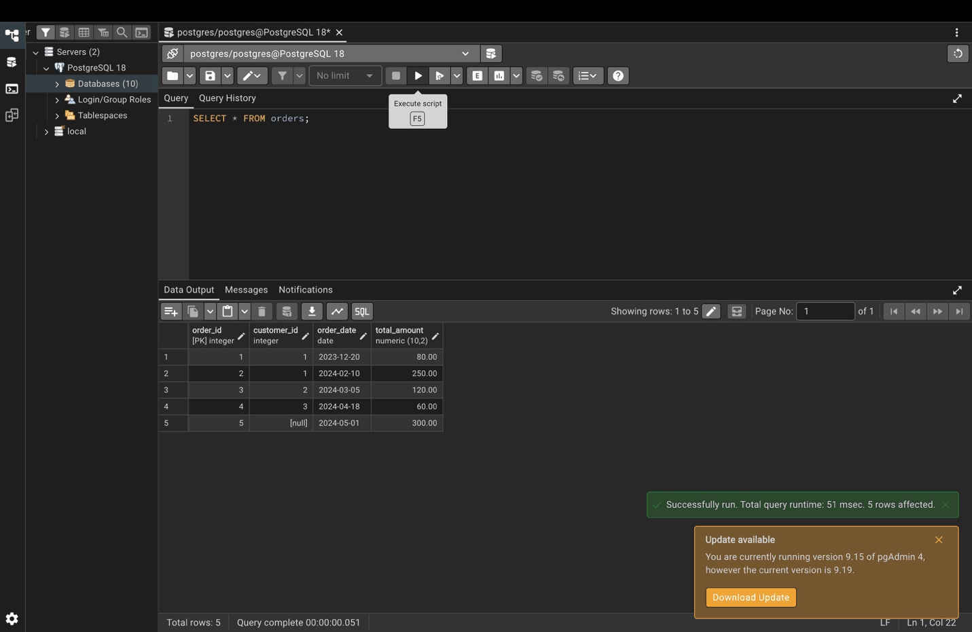

Part 2. Types of joins

Step 5. INNER JOIN
Only customers who placed orders are returned.
SELECT c.name, c.email, o.order_date, o.total_amount
FROM customers c
INNER JOIN orders o ON c.customer_id = o.customer_id;
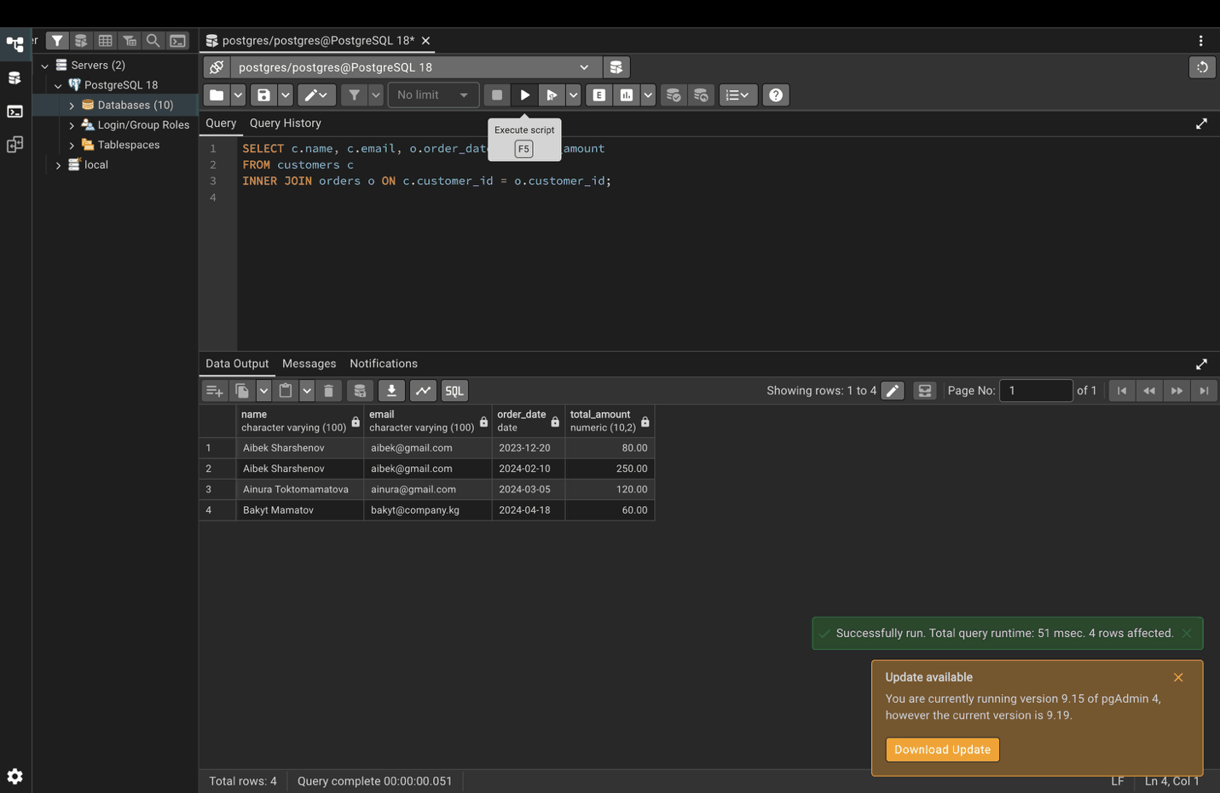

Step 6. LEFT JOIN
All customers are returned; Gulzat and Emir have no orders, so their order columns are NULL.
SELECT c.name, c.email, o.order_date, o.total_amount
FROM customers c
LEFT JOIN orders o ON c.customer_id = o.customer_id;
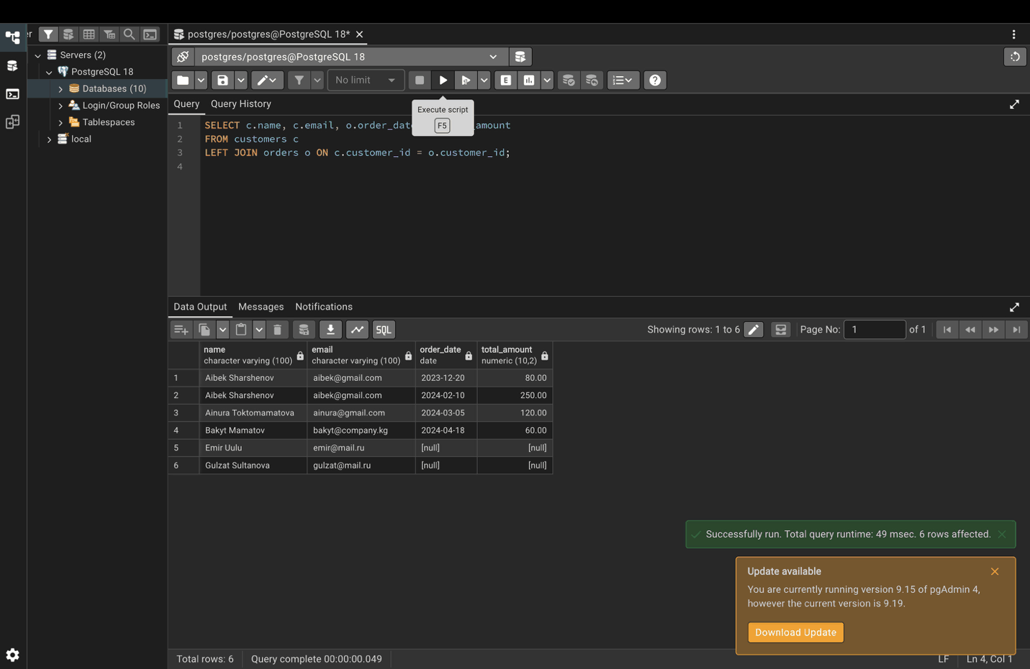

Step 7. RIGHT JOIN
All orders are returned; the order without a customer shows NULL name and email.
SELECT c.name, c.email, o.order_date, o.total_amount
FROM customers c
RIGHT JOIN orders o ON c.customer_id = o.customer_id;
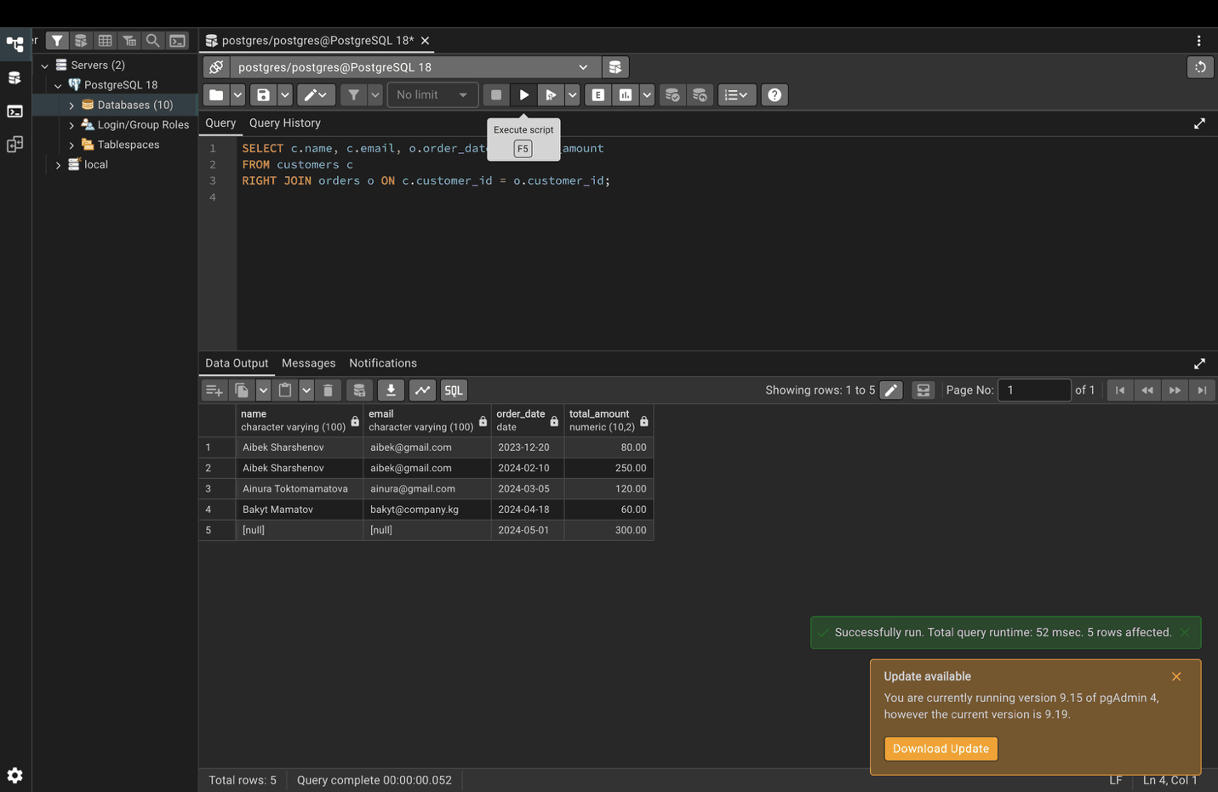

Step 8. FULL OUTER JOIN
All customers and all orders, with NULL where there is no match.
SELECT c.name, c.email, o.order_date, o.total_amount
FROM customers c
FULL OUTER JOIN orders o ON c.customer_id = o.customer_id;
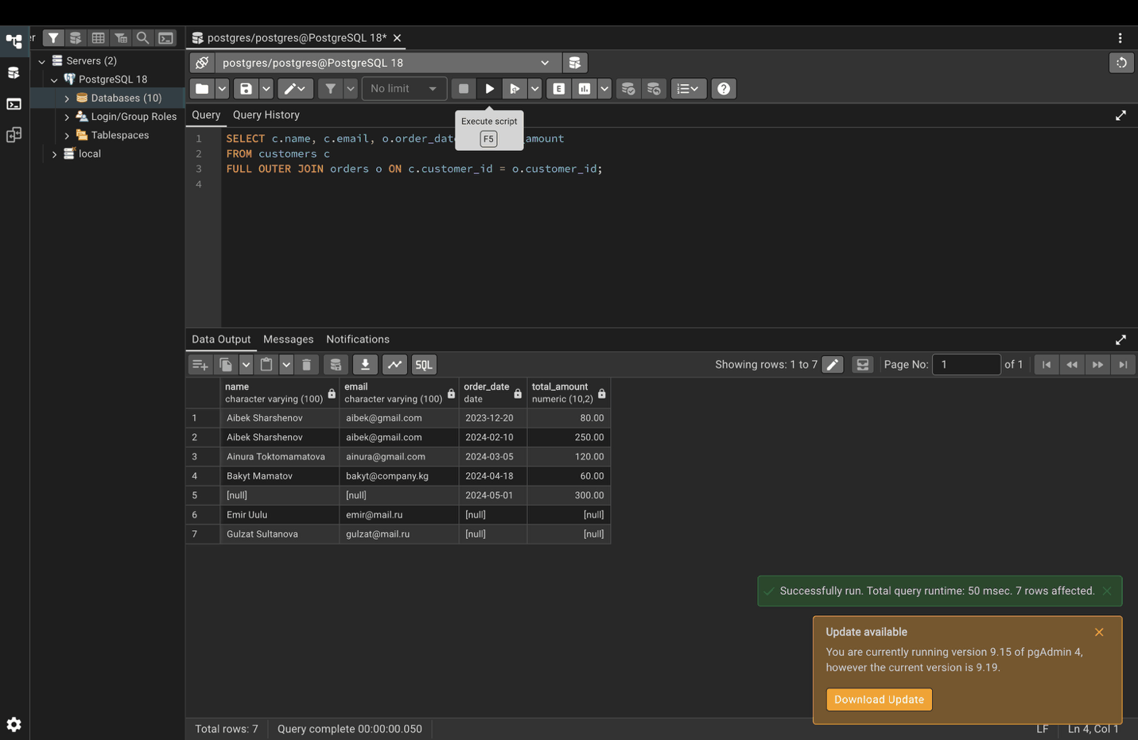

Step 9. CROSS JOIN
Every customer is paired with every product: 5 x 3 = 15 rows.
SELECT c.name, p.product_name
FROM customers c
CROSS JOIN products p;
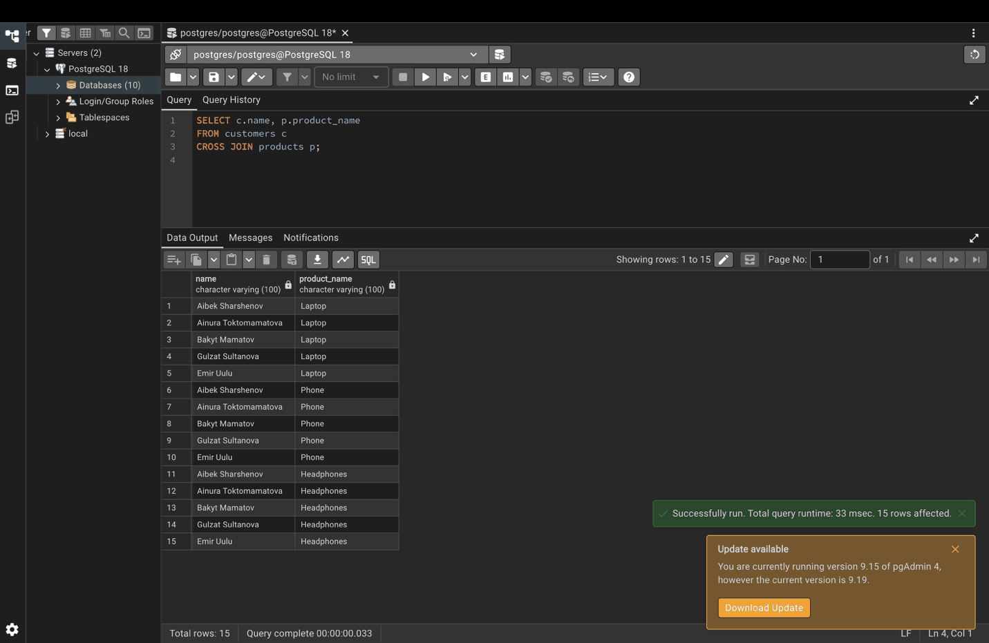

Part 3. Advanced join techniques

Step 10. Multiple table join
SELECT c.name, o.order_date, oi.quantity, p.product_name, p.price
FROM customers c
INNER JOIN orders o ON c.customer_id = o.customer_id
INNER JOIN order_items oi ON o.order_id = oi.order_id
INNER JOIN products p ON oi.product_id = p.product_id;
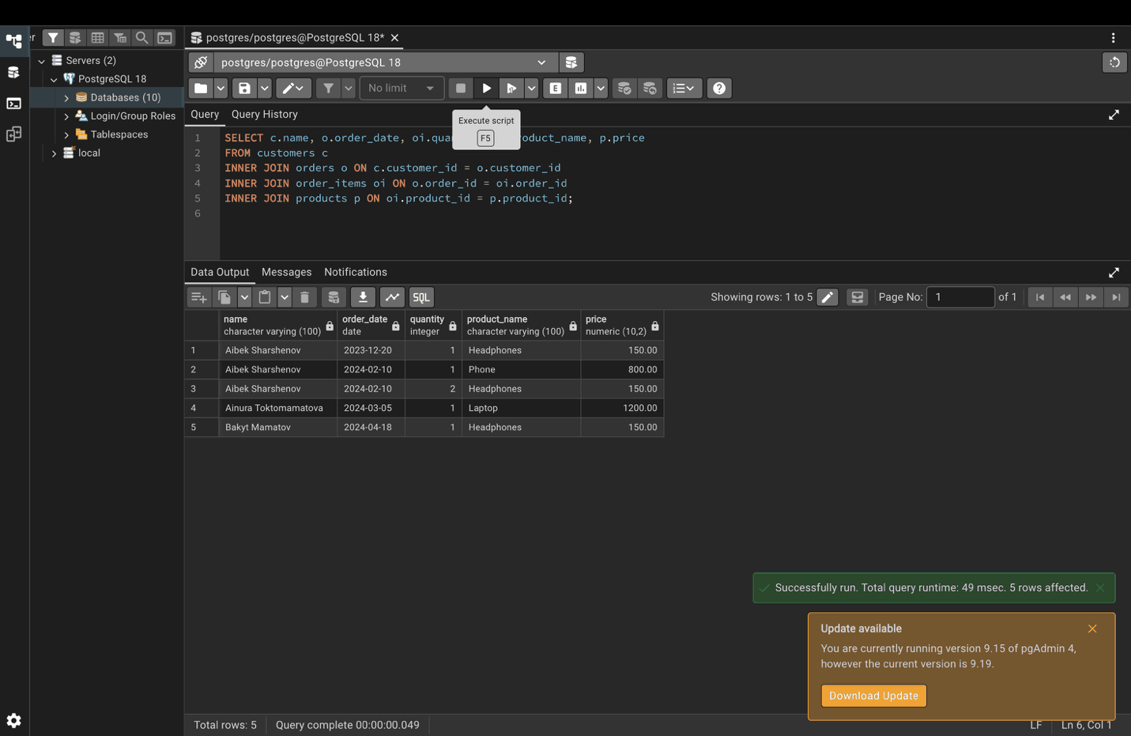

Step 11. Self join: employees and their managers
SELECT e1.name AS employee, e2.name AS manager
FROM employees e1
LEFT JOIN employees e2 ON e1.manager_id = e2.employee_id;
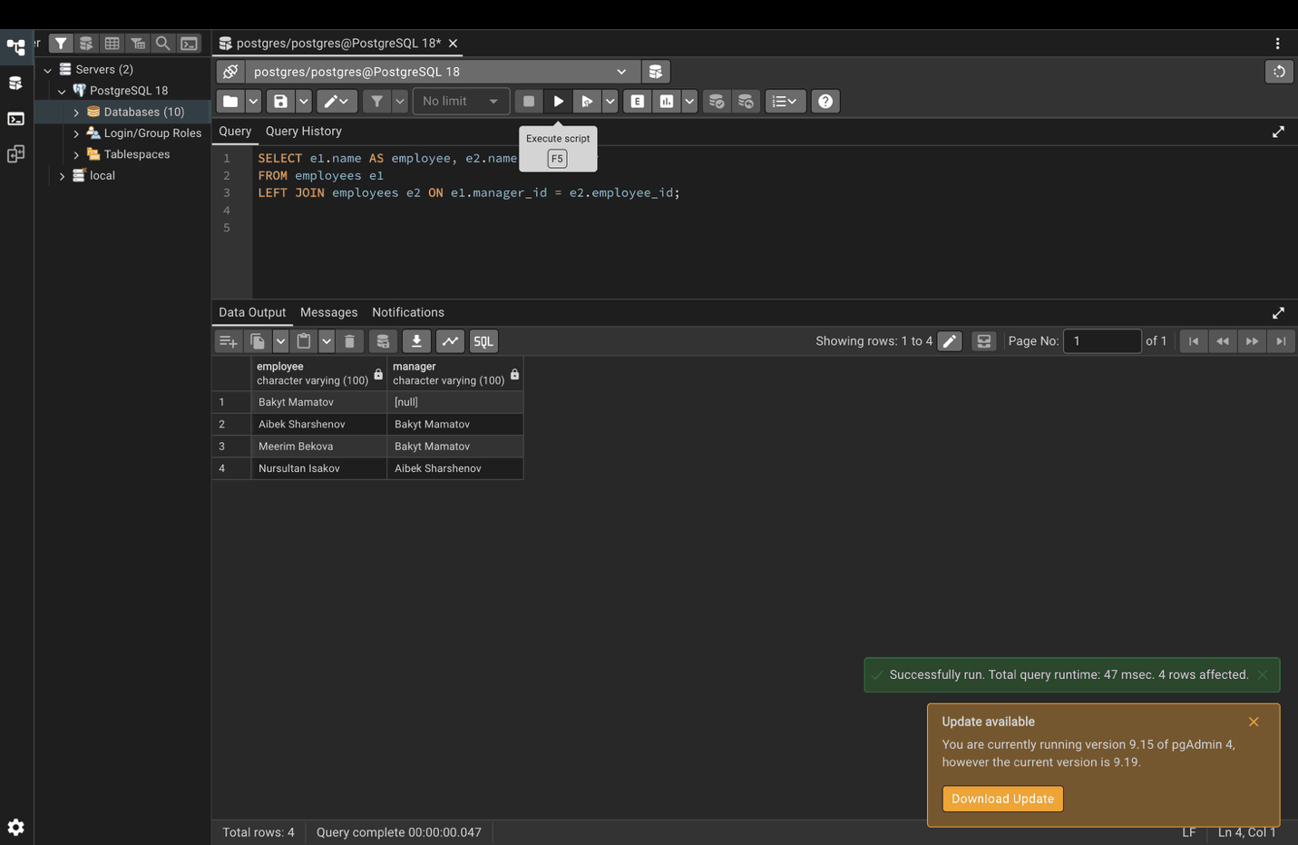

Step 12. Join with conditions
SELECT c.name, o.order_date, o.total_amount
FROM customers c
INNER JOIN orders o ON c.customer_id = o.customer_id
WHERE o.order_date >= '2024-01-01'
AND o.total_amount > 100;
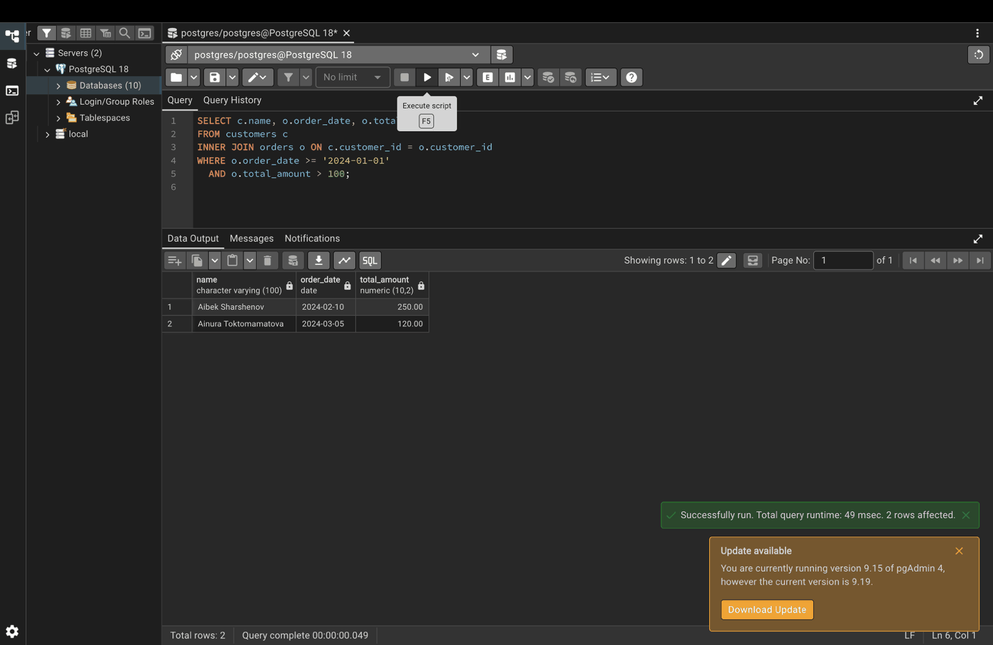

Part 4. Relationship types

Step 13. One-to-one: customers and their profiles
SELECT c.name, cp.phone, cp.city
FROM customers c
LEFT JOIN customer_profiles cp ON c.customer_id = cp.customer_id;
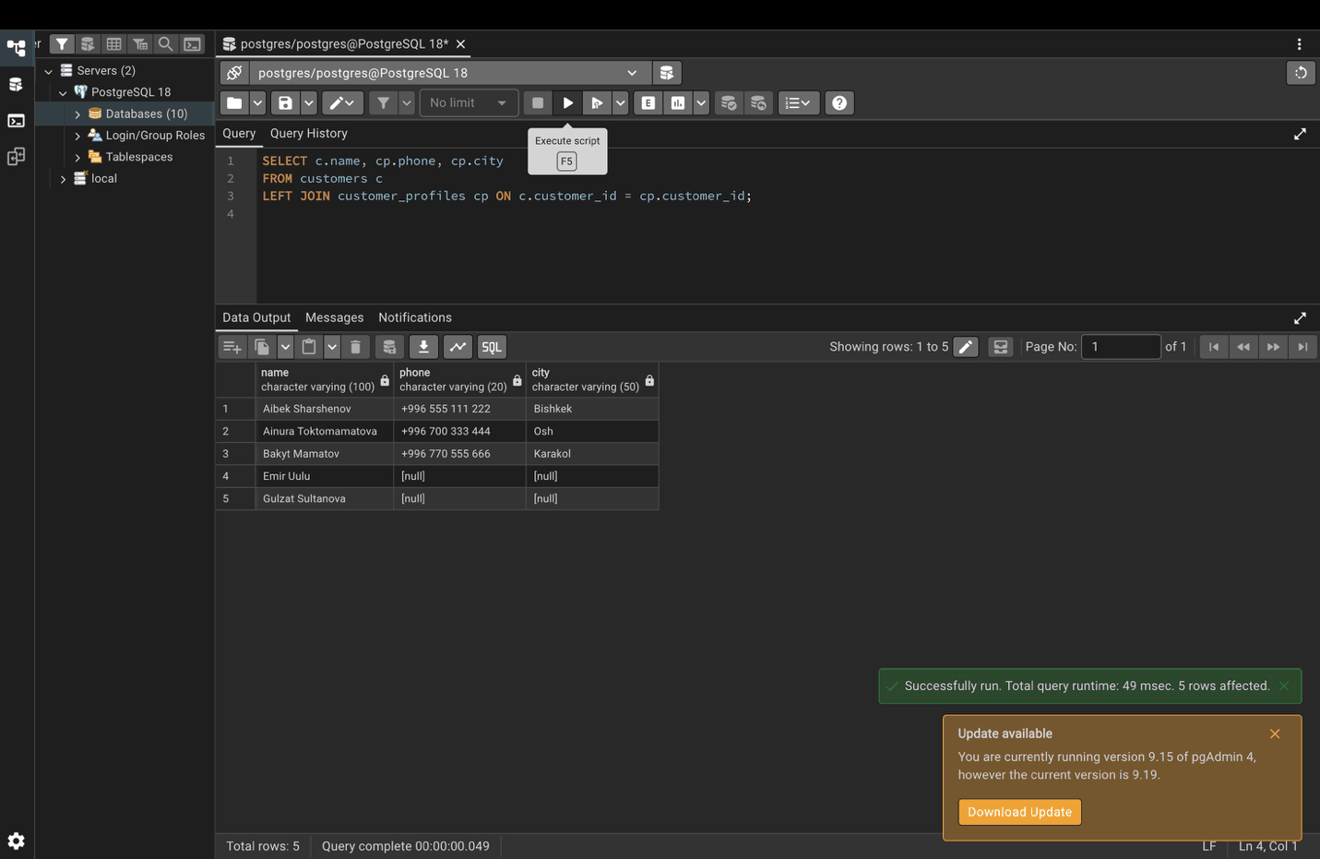

Step 14. One-to-many: customers and their orders
Aibek appears twice because he has two orders (the "one" side repeats).
SELECT c.name, o.order_id, o.order_date
FROM customers c
INNER JOIN orders o ON c.customer_id = o.customer_id
ORDER BY c.name, o.order_date;
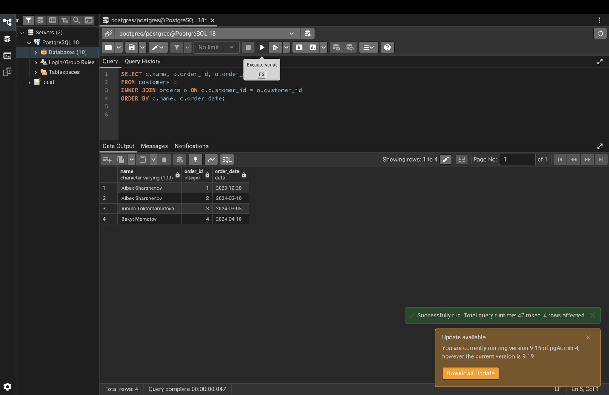

Step 15. Many-to-many: orders and products through order_items
order_items is the junction table: one order can have many products, and one product can be in many orders.
SELECT o.order_id, p.product_name, oi.quantity
FROM orders o
INNER JOIN order_items oi ON o.order_id = oi.order_id
INNER JOIN products p ON oi.product_id = p.product_id
ORDER BY o.order_id, p.product_name;
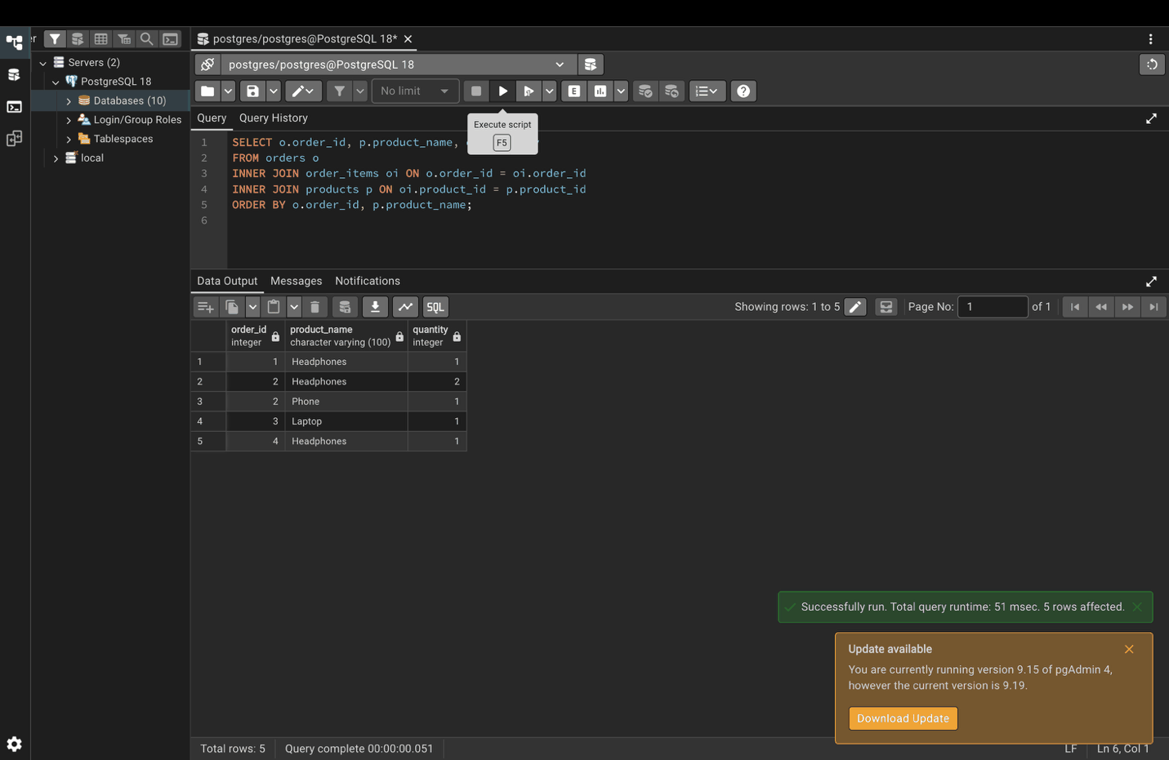

Part 5. Performance

Step 16. Create indexes on join columns
CREATE INDEX idx_orders_customer_id ON orders(customer_id);
CREATE INDEX idx_order_items_order_id ON order_items(order_id);
CREATE INDEX idx_order_items_product_id ON order_items(product_id);
SELECT tablename, indexname
FROM pg_indexes
WHERE schemaname = 'lab14' AND indexname LIKE 'idx_%';
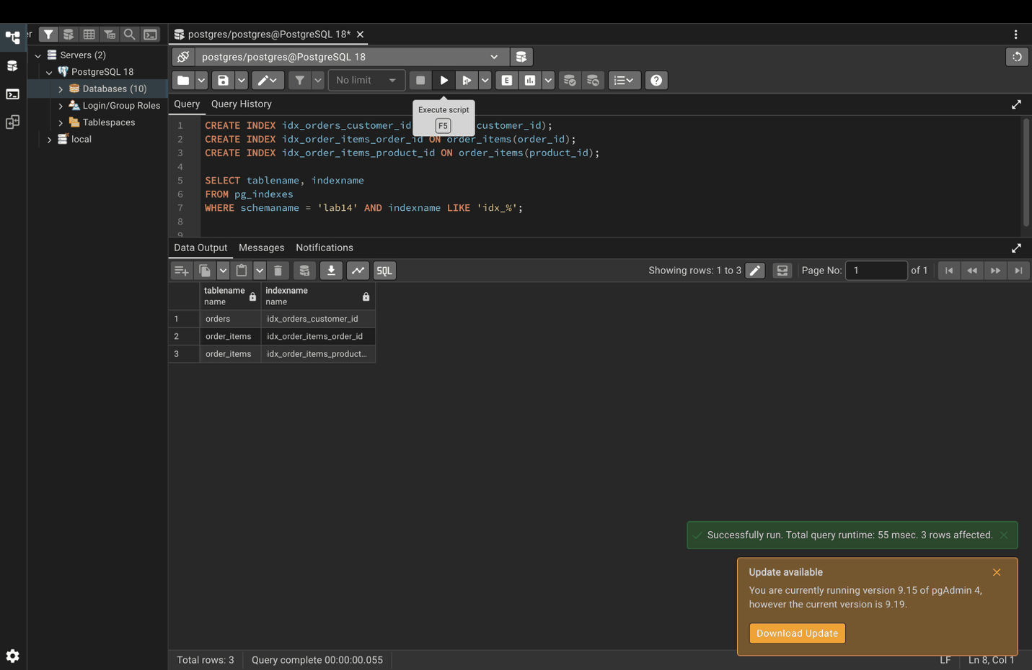

Part 6. Common pitfalls

Step 17. Cartesian product (wrong)
There is no join condition, so every customer is paired with every order (5 x 5 = 25 rows). The correct version is the INNER JOIN in Step 5.
SELECT c.name, o.order_date
FROM customers c, orders o;
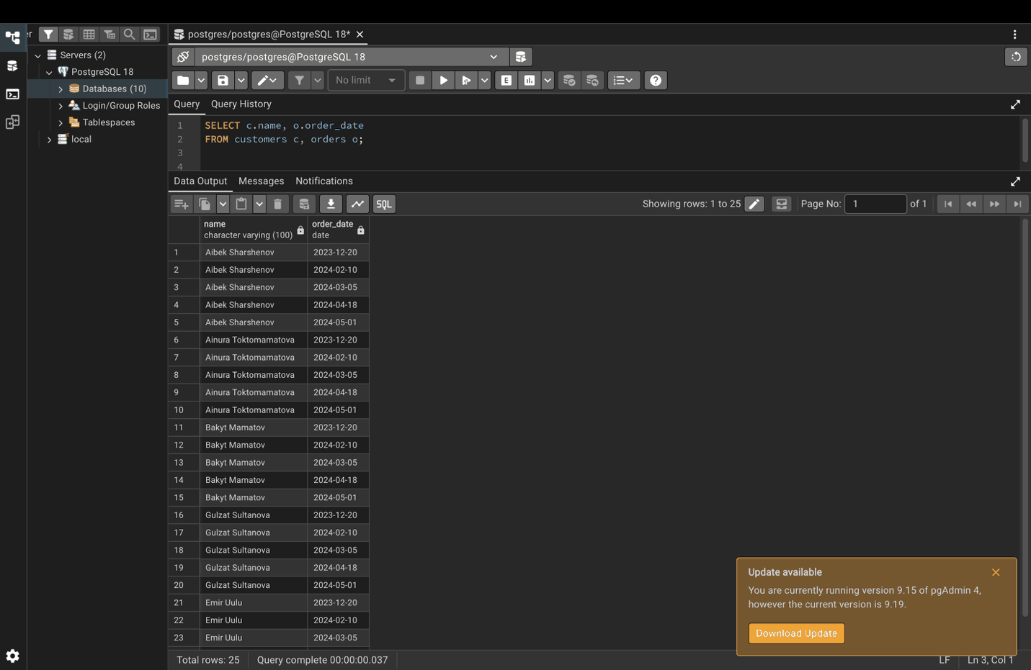

Step 18. Find customers without orders
SELECT c.name
FROM customers c
LEFT JOIN orders o ON c.customer_id = o.customer_id
WHERE o.customer_id IS NULL;


